**A’Level Art transition work from year 11 to 12.**

Firstly if you are considering Art A’level can you go on to a really valuable website 'The Student Art Guide' [www.studentartguide.com](https://eur01.safelinks.protection.outlook.com/?url=http%3A%2F%2Fwww.studentartguide.com%2F&data=02%7C01%7Csmeekcom%40kingswoodsecondaryacademy.org%7C6397747e5edc4ada2a6708d7d4dd6358%7Ca091745ab7d84d7ab2a61359053d4510%7C0%7C0%7C637211919631775615&sdata=M5S2ahkmhaBEOeObnAAE69yuLjSlF%2Fogo0U4TuJuT9o%3D&reserved=0) where you can see the standard set nationally at A level.  You will also gain some Art careers knowledge here if Art is your passion and you would like to turn it into a job.

The first topic Year 12 will encounter is based on 'Natural Forms' and in order to prepare for this you need to:

1. Create 20 (yes twenty!) 20 x 20 cm studies using a wide range of media (don't over rely on 'traditional' media - think outside of the box... i.e. not just a pencil!) of a selection of natural forms (such as shells, sections of vegetables/fruit etc. - be imaginative!).  Before you start sketching... consider the composition i.e. filling that 20 x 20cm space and think of the surface you are working on - don't automatically go for paper!  For example you might use an envelope, wrapping paper, napkin...

One piece must be brought to your sixth form interview where you will be asked about it.

2.  Go on line to see videos from the Georgia O'Keeffe exhibition at the Tate. Copy the web link from at least 3 clips into a word or power point and give a brief overview of what the video showed/taught you bullet points are fine.

Then put together a visually exciting A2 presentation that fully explains her influences, media used and working methods, ideas, links with the Year 12 topic 'Natural Forms' and includes some examples of your colour studies (copies) of her work.

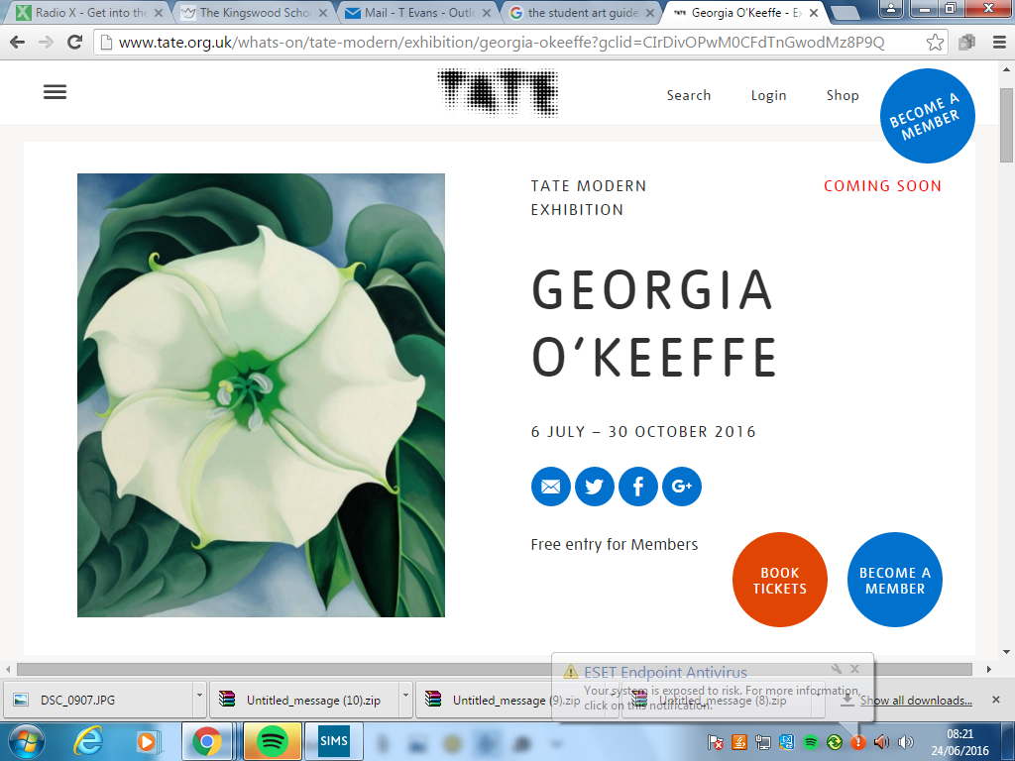

Any questions email Mrs T Evans at tevans@kingswoodsecondaryacademy.org